

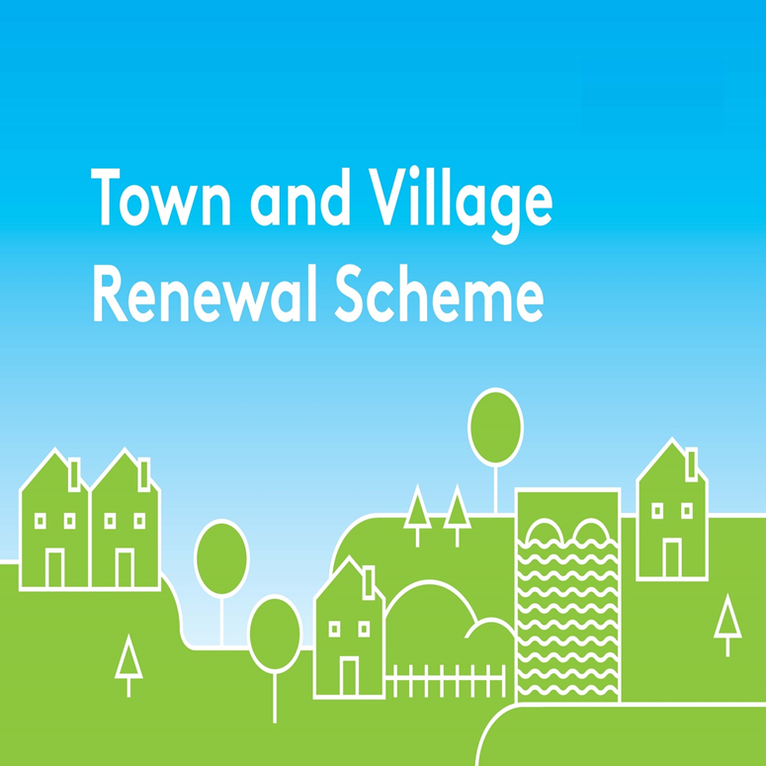

**2022 Application Form**

Please complete a separate application form in respect of each proposal.

All queries should be addressed to: [townandvillage@drcd.gov.ie](mailto:townandvillage@drcd.gov.ie)

**Application Reference No**

**APPLICATION FORM**

**This form should be completed by Local Authority personnel and returned by e-mail to** [**townandvillage@drcd.gov.ie**](mailto:townandvillage@drcd.gov.ie) **by close of business on 22nd July 2022**

**Notes:**

1. The number of applications that can be submitted by each Local Authority for grant funding (using this form) is 6 (max)

* 5 applications of between €20,000 and €250,000
* 1 application of between €20,000 and €500,000

(b) Further streams of funding under the 2022 Scheme:

* 2 applications up to €50,000 each under the Project Development Measure (Using the separate Project Development Application Form)
* 1 application up to €50,000 for a specific County Marketing campaign (Separate form provided)
* Up to 2 applications for up to a total of €400,000 under the Building Acquisition Measure (Separate form provided)

**(c) 1 of the applications from section (a)** must be in respect of Towns/Villages that have not previously received funding under the Town & Village Renewal Scheme in the last 3 years. (Funding received under the 2020 Accelerated Measure will not be considered for these purposes).

**Name of Local Authority:**

**Town/Village covered**:

**Postal Address of project:**

**Eircode or XY (ITM format)**

**Coordinates of the project:**

**Amount of Grant Funding Requested[1] :**

**Contact Name (Local Authority):**

**Contact email address:**

**Contact phone No:**

**Project Details:**

|  |
| --- |
| 1. **Project description (max 30 words) – Details may be used for Press Release / website:** |

1. **Project Details (Max. of 300 words): A detailed project proposal may be appended to this application. (Maximum 5 Pages for grant funding up to €250,000 and max of 10 pages for grant funding from €250,000 to €500,000):**

**3. (a) Does the proposed project involve works to a building/property or lands that are not in the ownership of the applicant? If yes, provide details of the current owner/s.**

**(b) If the building/property is not in the ownership of the LA or community group partner, has permission has been granted by the owners to carry out the proposed works and that a lease of a minimum 15 years from project approval date is achievable?**

|  |
| --- |
| 1. **Has this town/village received public funding previously e.g. REDZ, T&V, CLÁR, ORIS, RRDF, LEADER etc.? List scheme, year and funding amount.** |

|  |
| --- |
| 1. **Explain the rationale for the choice of Town/Village, identify existing assets, amenities, accessibility, environmental aspect, retail mix, etc., and any deficits that need to be addressed or opportunities that can be built on, and how the project will make a positive impact on the town/village (Max. of 300 words).** |

|  |
| --- |
| 1. **Are there any other applications pending for public funding for this project?** |

|  |
| --- |
| 1. **If this town/village is also the subject of an RRDF application, explain the rationale for submitting this application to the Town and Village Renewal Scheme and how this links with the RRDF application.** |

|  |
| --- |
| 1. **Who will be implementing the project? Please provide details of other stakeholders involved. (*Please note per the scheme outline, Section 7 Local Authority Costs, where works are to be undertaken in-house by the LA, a breakdown of these costs must be included in the application form and a rationale provided for same. Where LA staff costs are included they must be proportionate to the overall cost of the project, and identified at application stage*)** |

|  |
| --- |
| 1. **To what extent will this project address the United Nations Sustainable Development Goals (SDGs)?** |

1. **Financial Details:**

|  |  |
| --- | --- |
| Local Authority VAT No.: |  |
| Tax Registration No.: |  |
| Tax Clearance No.: |  |
| CHY Number (if applicable) |  |

1. **PROJECT COSTINGS:**

Please provide detailed breakdown of all elements of the proposed works including any administration/other fees/costs:

|  |  |
| --- | --- |
| **Project Element** | **Estimated Cost (inclusive of VAT)** |
| **1.** | € |
| **2.** | € |
| **3.** | € |
| **4.** | € |
| **Local Authority Costs, (if applicable)** |  |
| **1.** | € |
| **2.** | € |
| **Contribution in Kind, (if applicable)** |  |
| **1.** | € |
| **2.** | € |
| **Total Project Cost** | € |
| **Grant Aid amount sought:** (Max of 90% of total project costs) | € |
| **Match Funding: (Min 10% of total cost)** | € |
| **Breakdown of Match funding:**   1. **(a): Amount of Cash Contribution:**   **(Minimum 5% of total project costs)**  **(b): To be supplied by:** | 1. € |
| 1. **(a): Amount of Contribution in Kind:**   **(Max 5% of total project costs)**  **(b): List details of the Contribution in Kind to be provided:**  **(c) To be supplied by:** | 1. €   (c) |
| **Any other relevant information:** |  |

1. **Timeline:**

Provide a timeline for commencement and completion of the project.

|  |  |  |
| --- | --- | --- |
| Commencement date | Completion Date | Indicative time frame (weeks/months): |
|  |  |  |

The following forms should be returned to the Department by **22nd July 2022**:

(i) Application form

(ii) Application Overview sheet and

(iii) The Expression of Interest Overview sheets.

Please ensure that these forms are fully completed as an incomplete application may result in the project not being considered. Completed forms should be returned by e-mail to [townandvillage@drcd.gov.ie](mailto:townandvillage@drcd.gov.ie) **by 22nd July 2022.**

**Use of Data:**

The Department of Rural and Community Development (DRCD) is the Data Controller and the lawful basis for processing is ‘the performance of a task carried out in the public interest’.  Applications are submitted to the Department through the Local Authority for each area for this programme.  The Department may engage a Third party as a data processor.  The information on this Application Form will be used by DRCD for the purposes of processing the application. Further information may be sought by the Department to clarify aspects of the project proposal. The Department may draw on broader, more specialist expertise where required, and such information as considered necessary to complete an assessment of your application may be shared with those experts.

The Applicant, the Department and the Third party are subject to the data protection and privacy laws of Ireland and the EU, in particular the Data Protection Act 2018 and Regulation (EU) 2016/679, known as the EU General Data Protection Regulation (“GDPR”). Any personal information which you provide as part of the application process will be obtained and processed in compliance with Data Protection legislation.

The Department retains the right to disclose for the purposes of a request under the Freedom of Information Act 2014 or otherwise, in connection with the funded project(s) –

i.              any information supplied by the Applicant to the Department,

ii.            any relevant data gathered by the Department in administering grant aid to the project, except where the information is considered to be personal or commercially sensitive.

**Declaration by Local Authority:**

This declaration must be signed by an officer authorised at a senior level within the lead applicant organisation i.e. at least Director of Services level in a Local Authority.

I confirm that I have read and understood this document and declare that the particulars supplied in this application are true and correct and that –

* This project is eligible under the Town and Village Renewal Scheme criteria.
* The costings are accurate and reasonable.
* Match funding is available for the project and that evidence and source of the match funding is held on the project file.
* Evidence of ownership (if applicable) or the consent of the landowner is on the project file.
* The project procurement process should be in line with EU Public Procurements Requirements (EU Directive 2014/24) and Public Procurement Guidelines.
* The project conforms to the LECP and other local or regional plans.
* That a consultation process was undertaken with representatives of the community or business interest of the town/village and that the project was identified through the consultation process undertaken.
* No funding has been allocated for the same works from any other public funding sources.

Proof of the above is not required at the time of application but must be available to the Department or its agents on request.

The Local Authority acknowledges the information regarding the use of data set out above and gives consent to the Department of Rural and Community Development for the sharing of all information, personal or otherwise, contained in this application and any attachments accompanying it, for the purposes of application processing in accordance with data protection legislation.

Signed on behalf of __________________________ (Local Authority)

Signature _______________________________

Name in Block Capitals_____________________

Position_________________________________

Date_____

**Appendix A:** Category of project submitted: Please indicate which Scheme Priority Category this project fits into (please refer to Scheme Outline for full descriptions):

|  |  |  |
| --- | --- | --- |
| **Priority Category** | **Type of project** | **Mark X at the appropriate project type** |
| **Priority A1 Projects** | Projects that bring vacant and derelict buildings and sites back into use as multi-purpose spaces |  |
| Projects that bring vacant properties in Town Centres back into use as Remote Working Hubs, including the repurposing of existing community or publicly owned buildings in town or village centres to facilitate remote working. |  |
| **Priority A2 Projects** | Regeneration projects that assist in revitalising our rural towns and villages, in line with Town Centre First Policy, (e.g. projects that drive greater economic activity and footfall, address vacancy and dereliction, ensure re-use of heritage and existing buildings |  |
| New build community centres (where there is a clearly identified and defined need) |  |
| Projects to develop parks, plazas, public outdoor dining spaces, green spaces (including allotments and community gardens) and recreational spaces/amenities(including skate parks, basketball courts, tennis courts, etc) in town centres to make them vibrant hubs for community enjoyment, and to increase footfall for local businesses |  |
| **Priority B Projects** | Projects that support and enhance the night-time economy in line with emerging recommendations from the Night-Time Economy Taskforce. |  |
| Projects to support the upgrade and enhancement of shopfronts and street facades (including murals) in towns and villages. |  |
| Enhancement of heritage assets (e.g. local museums/tourism attractions focused on historical aspects of the area, heritage sites/buildings, etc) located in towns and villages, including energy efficiency measures. |  |

1. Where grant funding of €250,000 to €500,000 is being requested an additional submission of max 10 pages to support the application may be submitted.